*Jenkins Pipeline Lab*

To create a basic Pipeline in the Jenkins web UI, follow these steps:

• Click New Item on Jenkins home page

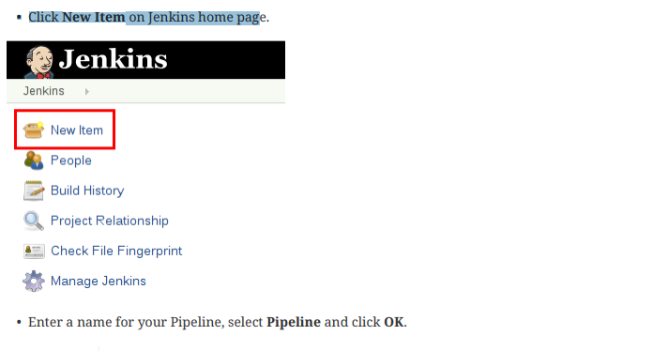

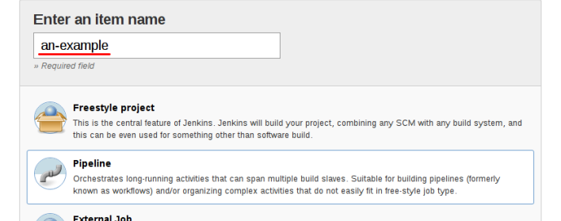

Press OK

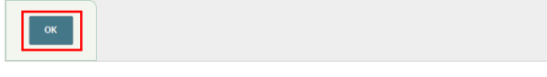

In the Script text area, enter a Pipeline and click Save. 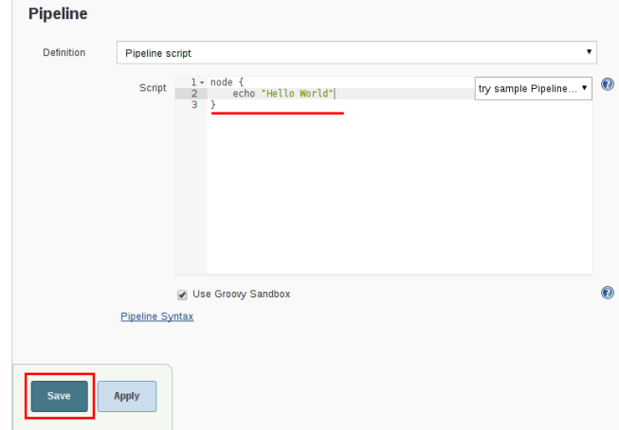

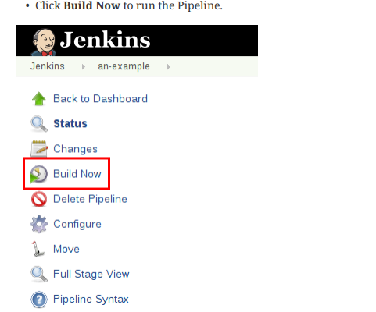

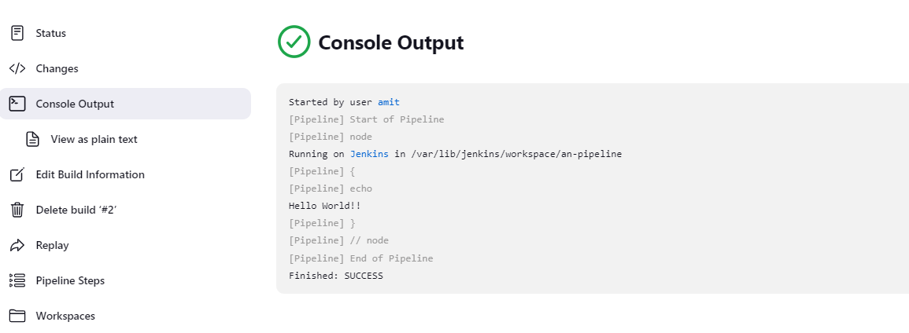

Built-in Documentation

The built-in documentation can be found globally at: localhost:8080/pipeline-syntax/, assuming you have a Jenkins instance running on localhost port 8080. The same documentation is also linked as Pipeline Syntax in the side-bar for any configured Pipeline project

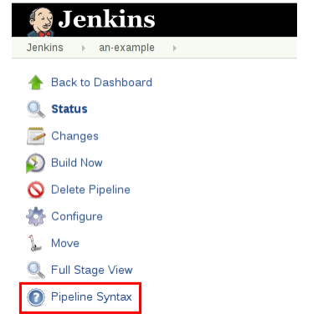

**Snippet Generator** The built-in "Snippet Generator" utility is helpful for creating bits of code for individual steps, discovering new steps provided by plugins, or experimenting with different parameters for a particular step. The Snippet Generator is dynamically populated with a list of the steps available to the Jenkins instance. The number of steps available is dependent on the plugins installed which explicitly expose steps for use in Pipeline.

To generate a step snippet with the Snippet Generator:

1. Navigate to the Pipeline Syntax link (referenced above) from a configured Pipeline, or at localhost:8080/pipeline-syntax.

2. Select the desired step in the Sample Step dropdown menu

3. Use the dynamically populated area below the Sample Step dropdown to configure the selected step.

4. Click Generate Pipeline Script to create a snippet of Pipeline which can be copied and pasted

